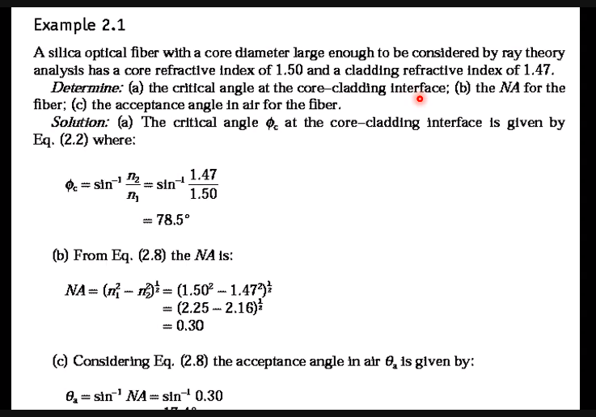

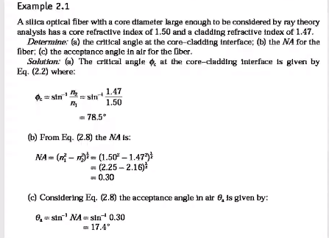

A typical relative 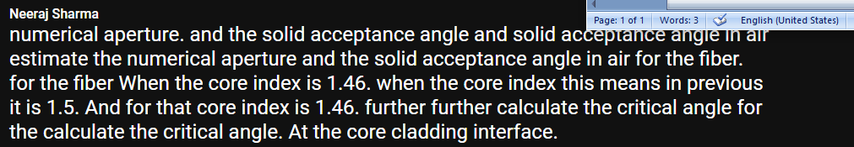

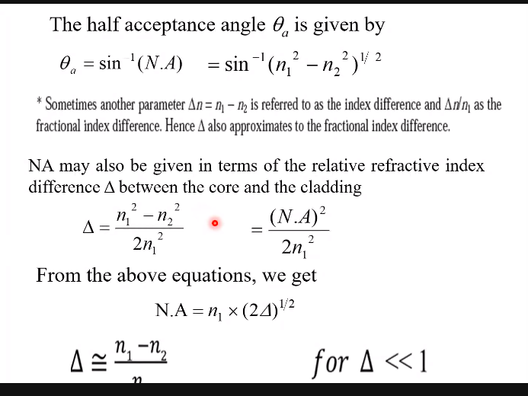

Na =0.206

Critical angle = 81.9 degree

Acceptance angle = 12.05 degree

Solid acceptance angle = 0.13rad

